Words from the Lehigh Valley Regional Homeless Advisory Board

When we think of homelessness, what are our first thoughts? Someone holding a sign on the side of the highway. Someone begging for any spare change you might have. Or maybe your view of homelessness is a little further removed. Perhaps you picture the bread lines of the 1930’s or a scene from a movie portraying the unhoused as a nuisance or a criminal. You probably also think about the amount of people you see right here, in the Lehigh valley, begging for help.
For many of the “housed” population, helping combat homelessness seems like a problem out of our collective hands. But those of us who are housed are not that far off from being homeless. As the cost of living rapidly increases and wages stay stagnant, one unexpected event can tragically alter someone’s life and put them at risk for homelessness.
To fully understand the breadth of the homelessness issue in our country and right here in the Lehigh Valley, Housing and Urban Development (HUD) conducts a nationwide Point-In-Time count (PIT). This survey sends volunteers out into the community to talk to those staying in shelters, safe houses, and outdoor encampments and assess their financial, personal, and mental state to help uncover the root causes for homelessness.
The following data has been taken from the results of the 2022 Point-in-Time count conducted in the Lehigh Valley. Because of Covid-19, a Point-in-Time count could not be conducted in 2021 so all data from 2022 will be compared with the data from the 2020 count which was conducted prior to the Covid-19 outbreak.
The 2022 PIT Count in the Lehigh Valley identified:
- 547 households made up of 921 people experiencing homelessness
  - This is a 26% increase in the number of households over the 2020 count and 36% increase in the number of people.
- The LVRHAB reported 36.9% of the households and 40% of the individuals counted in 2022.

There were alarming increases between 2020 and 2022 for the following populations:
- 51% increase in families with children
- 93% increase for veterans
- 46% increase in individuals experiencing chronic homelessness
- 46% increase for households experiencing domestic violence.

This supports the need for additional resources dedicated to these populations.

However, there was a decrease in the count of unsheltered people:
- 81 households made up of 89 people in 2020
- 69 households made up 80 people in 2022
- This represents a 13% decrease in unsheltered households and 9% decrease in individuals

It is likely that the emergency shelter hoteling programs run by LVRHAB-member agencies using ERAP and other funds helped keep the unsheltered numbers down.

Of the 80 unsheltered people:
- One was a transition aged youth (18-24 years old)
- 32 were experiencing chronic homelessness (a 28% increase over 2020)
- 10 had chronic substance abuse issues
- 39 had a disability,
- Nine were veterans (an alarming 200% increase)
- Four were victims of domestic violence (also an alarming 200% increase from 2020).

These numbers only reveal a fraction of the issue. Between the lack of affordable housing in the Lehigh Valley, landlords who refused to accept rental assistance and other housing funds and the lack of fair wages; it can be hard for someone to bounce back on their feet. These results also indicate a large need for emergency shelter resources in the Lehigh Valley and more funds directed towards the shelters currently operating.

Connect to Home: The Coordinated Entry System of the Eastern PA Continuum of Care

To combat the homelessness crisis, the Lehigh Valley Regional Homelessness Advisory Board (LVRHAB) piloted Connect to Home: The Coordinated Entry System for the Eastern Pennsylvania Continuum of Care (CoC) in December 2016. The goal being to assess people who are experiencing homelessness or are at imminent risk and refer them to available shelter and housing solutions.

According to the 2022 Gaps Analysis, conducted by Diana T. Myers & Associates for the Eastern Pennsylvania Continuum of Care, the Coordinated Entry System enrolled 5,019 households in the Homeless Management Information System (HMIS) in the Eastern Pennsylvania Continuum of Care in 2021.

- 22% percent of those households were in the Lehigh Valley,
- Where 1,086 households were enrolled (689 in Lehigh County and 397 in Northampton County).
- 69% percent were assessed through the 211 system
- Only 31% were able to access assistance at a walk-in-center; this speaks to a need for more walk-in center sites and/or opening hours.

If we dig deeper into these statistics:

- 60% of those assessed were singles or couples and 40% were families.
- Over 45% of people assessed were white and nearly 75% non-Hispanic/Latino.
- One hundred people were experiencing chronic homeless,
- 38 were veterans,
- 158 were youth ages 18- 24, and
- 409 were fleeing domestic violence

Since we also know that people of color are disproportionately impacted by homelessness, this data warrants further examination both at the LVRHAB- and CoC-level. This is work that is has already started but merits further investment and resources.

Taken from the 2022 CoC Gaps Analysis
Race/Ethnicity | Percentage Assessed
White | 45.1%
Black/African-American | 26.9%
Multiracial | 3.6%
Race Unknown | 26.9%
Hispanic/Latino | 14.8%
Non-Hispanic/Latino | 74.4%

All populations listed above saw concerning increases in the PIT Count.

Only 14% of those enrolled by the LVRHAB exited to permanent housing (the percentage was 30% across the entire Continuum of Care); this was the about half the households exiting compared to the other four RHABs.

The average length of time on the By Name List (BNL) was 142 days (it was 109 days across the CoC); this was over two months longer than most of the RHABs. This speaks to a need to move households more quickly off the BNL and into permanent housing. However, a lack of affordable units, drastically rising rents, and conditions that make it possible for landlords to be exceedingly selective make this challenging. The Lehigh Valley needs more Rapid Rehousing resources (and emergency shelter options to keep households safe while they search for housing), but also more housing units. Therefore, the LVRHAB launched a Landlord Engagement program to build a pool of landlords to work with our clients.

According to the CoC, the Annual Housing Service Demand for the Lehigh Valley is:

- 746 households for Homeless Prevention (including 162 families),
- 601 for Rapid Rehousing (including 332 singles/couples and 269 families), and
- 295 for Permanent Supportive Housing (including 200 single/couples and 95 families).

The LVRHAB currently has 84 CoC-funded Rapid Rehousing (RRH) units and one ESG-funded unit. This is only 14% capacity to meet the need. This supports the need for all these resources, but especially Rapid Rehousing and Homeless Prevention.

While things like the Coordinated Entry system, Homeless Advisory Boards, and the shelters themselves are taking on the groundwork. The non-emergency helpline 211 (www.PA211.org) is also facing the issue head on. It was founded as a direct line for at risk people to be able to receive immediate help in finding shelter, financial assistance, and crisis intervention. For many who have used the service, it can be lifesaving.

After an extensive breakdown of the statistics for our valley, it can leave many wondering “What can I do?”. As for those who may not work in the emergency services sector, familiarize yourself with all these great programs. If you are aware of a friend, family member or coworker in crisis, you can connect them with the necessary help they need.

If you are a landlord struggling to find tenants, you are encouraged to join the Landlord Engagement program which is sponsored by the Lehigh Valley Regional Homeless Advisory Board. Landlords will become part of a network of peers who have agreed to rent to homeless or at-risk households. They will receive guaranteed rental payment, reimbursement for property damage or missed rent, case management for tenants, and other support. Property owners offer valuable housing options for qualified families. With federally funded rental assistance provided on their behalf, tenants can locate housing, including single-family homes, doubles, townhouses, and apartments. Landlords will receive guaranteed monthly rent payments in addition to $1,000 Signing Bonus for first unit. Subsequent properties will receive $500 Signing Bonus for second unit and $250 Signing Bonus for each additional unit.

Reflection question
After reading through those particularly shocking statistics, how has your view of homelessness changed?
How can you help to solve this problem in our community?
Words from the Justice and Advocacy Committee of the Lehigh Conference of Churches
(taken from the Lehigh Conference of Churches Justice and Advocacy Committee http://ja.ppjr.org/)
Hungry and Homeless in the Lehigh Valley
Why and What We Can Do About It
By Robert Walden
The Lehigh Valley, like much of the nation, has been facing a rapidly growing demand this year for emergency food and housing assistance, as funding for COVID-related state and federal programs has been winding down. Food insecurity was high (about 10% of Lehigh Valley
households) and increasing prior to the COVID epidemic, but this year demand for emergency
food has exploded.
The Lehigh Conference of Church’s Conference Kitchen, which offers three meals a day Monday through Friday, now serves daily breakfast and dinner to almost 100 people and lunch to about 140 people. The demand for food assistance reflects in part the rising cost of housing;
rents in Lehigh Valley communities have gone up typically by 40 to 50 percent in the past three years, and the median price of homes for sale has risen almost as much. Longer term issues have contributed to the current crisis, too. Most of Pennsylvania’s psychiatric facilities, including Allentown State Hospital closed a dozen years ago without providing alternative supportive
housing for former residents, so that now people with significant mental disabilities often end up homeless or in jail.
Also, Pennsylvania is one of 20 states that has not raised minimum wage above the federal rate set 13 years ago of $7.25 per hour, so that wages have not kept up with cost of living for many workers.
Eviction filing rates were high and rising prior to the COVID epidemic (affecting 11.2% of Lehigh Valley renters in 2019); however the Pennsylvania and CDC eviction moratoriums in 2020 and renter assistance programs have temporarily reduced the number of eviction filings more recently. The many Lehigh Valley agencies that provide housing related assistance have been putting progressively more resources into keeping people sheltered, especially during the COVID pandemic, but as reflected in the annual Point in Time (PIT) count, the need still exceeds available resources. The Russia-Ukraine War, the COVID pandemic, and rising inflation are all contributing to the current hunger and housing crisis, but there is more to the story. Rapidly rising housing costs during COVID began when businesses asked employees to vacate office buildings and work from home. Many workers took the opportunity to move from metropolitan areas like New York City or Philadelphia to places like the Lehigh Valley with its relatively much lower cost of living. Also, Wall Street venture capital firms no longer found it profitable to invest
in new office buildings, so turned to residential real estate, buying up retail rental properties, raising rents to generate more income to buy yet more properties – and these acquisitions have often been financed on favorable terms through federal loan agencies Fannie Mae and Freddie Mac.

What We Can Do About It
There are, of course, many options for individuals, groups, and congregations to respond to the immediate need for emergency food and safe affordable housing.
- There is always a need for volunteers and donations to assist local food pantries and soup kitchens
- Organizations such as Habitat for Humanity need volunteers to help with construction of new homes and
- Renovation of older homes in need of repairs or weatherization.
- Funding for programs that provide food and housing assistance comes primarily from federal, state, and local governments; and citizen advocacy can significantly influence spending priorities.
– For example, last month when the 2023 Lehigh County proposed budget was up for public discussion, local citizens attended the Board of Commissioners meeting to speak in favor of a budget amendment to allocate $200,000 for eviction prevention. After extended testimony, Commissioners approved the amendment unanimously.
– Also, local governments are still making decisions about the use of American Rescue Plan (ARP) funds, and Bethlehem, for example, has recently asked for public input to set priorities for allocating the city’s share of ARP funds, including the possibility of a year-round homeless shelter.
– Member agencies of the Lehigh Valley Regional Homeless Advisory Board (LVRHAB) have been working together cooperatively to assist people facing homelessness, but it’s time for regional municipalities – city, township, and county governments and planning commissions–to begin working together to prioritize construction of affordable housing while providing transitional housing and services
for people at risk for homelessness.
All of these responses are necessary but do not address the root issue of structural inequality which enables a relatively small number people to accumulate enormous wealth (and multiple homes) at the expense of everyone else – especially the most vulnerable people in our communities.

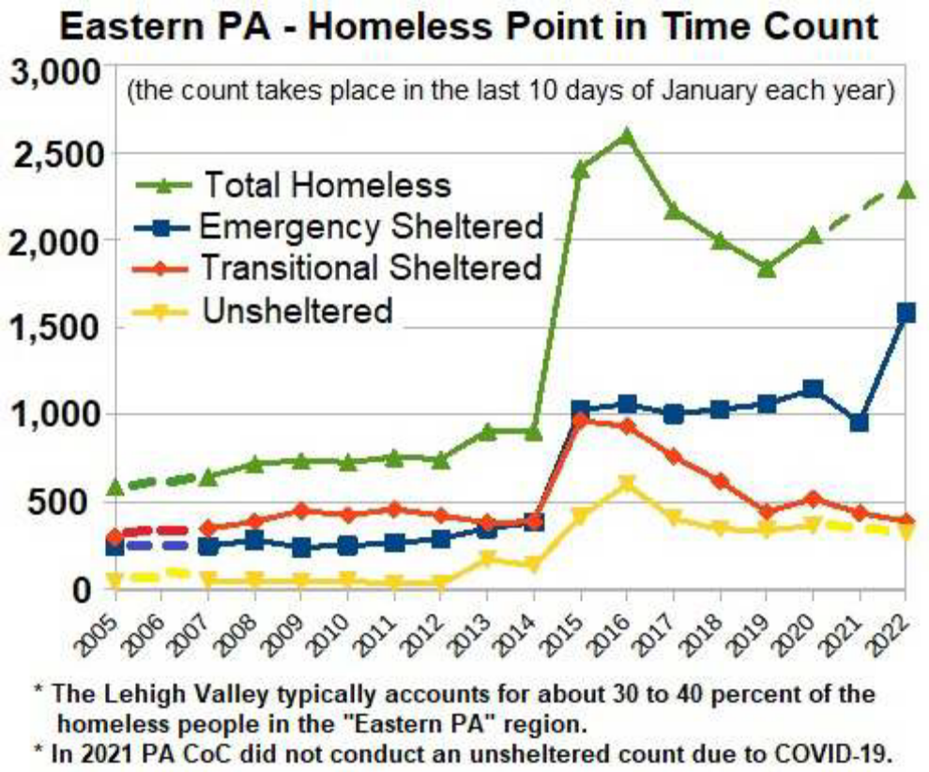

Additional Resources and Media:

Videos produced by the National Coalition for the Homeless:
"Faces of Homelessness I" The highly regarded NCH video that features images of America’s homeless people. This 13-minute video features images taken by award-winning photographers from around the country accompanied with powerful homeless-themed music that enables the viewer to get a sense of who is homeless in America. Available on YouTube. https://www.youtube.com/watch?v=OlQzS7aXLBk&t=1s
"Faces of Homelessness II" DVD was done by a trio of student filmmakers who interviewed a number of homeless people in the nation’s capital. Available on YouTube. https://www.youtube.com/watch?v=aUAYjt67IM4
"The National Coalition for the Homeless: Bringing America Home" A short documentary that outlines the history and promotes the work of the National Coalition for the Homeless. Available on YouTube. https://www.youtube.com/watch?v=m9oAX-oBMVU&t=13s
"The Invisible Class" A documentary that explores what it truly means to be homeless in America, challenging stereotypes and examining the causes of mass homelessness. https://www.youtube.com/watch?v=ZUz4Cd-nnrw
The National Alliance to End Homelessness: Parents and Kids talk about homelessness. https://www.youtube.com/watch?v=CX4TzWdDAFY

Videos produced by the Eviction Lab:

https://www.youtube.com/watch?v=INcFo3PxFZU
https://www.youtube.com/watch?v=gXqNtHtUa1U
https://www.youtube.com/watch?v=7f9dqQBYjcA

___________________________________________________________________________

Some Facts About Eviction:
It’s wintertime, so I can’t be evicted. Is that right?
Wrong. The eviction process is the same in summer and winter. The only exception is for Manufactured Homes, where the park owner must give a 30 day Notice to Quit for nonpayment of rent from September through March.
If I pay everything I owe, can I stop the eviction?
If the only reason you are being evicted is non-payment of rent, you should request that the MDJ enter a judgment of “Possession Granted if Money Judgment Not Satisfied.” This is also called “pay and stay” judgment. If you pay everything you owe on the judgment, including the court costs, to the landlord or to the constable before the lock-out, you will stop the eviction. But you will lose the right to pay and stay after the constable changes the locks.
I do not have anywhere to go. What should I do?
You need to find a place for both you and your belongings. You should not leave your possessions behind. Your landlord must safeguard your possessions, but only for a limited amount of time following an eviction and you can be charged a storage fee. However, a landlord cannot hold your possessions until you pay the rent you owe. If you cannot find a new place to live, then contact family or friends. You should also contact local shelters, although they may have waiting lists or other limitations on staying there.
What if my landlord is evicting me for something related to my disability?
You should ask for a reasonable accommodation of your disability if your landlord is evicting because of your disability. An example would be if your landlord is evicting you for behavior while you weren’t getting treatment. Your request would be to ask your landlord to stop the eviction and give you time to get treatment that will help your behavior. Another example would be if your landlord is evicting you for housekeeping violations and you cannot clean because of a disability. You could ask your landlord to stop the eviction and give you time to find someone to help you clean.

** Excerpts from https://allentowntenant.weebly.com/articles/the-eviction-process

___________________________________________________

The Fight for Economic Justice and Housing Security

Pulitzer Prize-winner and MacArthur “Genius” MATTHEW DESMOND re-imagines the debate on poverty in Poverty, By America (out this spring), making a new and bracing argument about why it persists in America: because the rest of us benefit from it. His previous book Evicted: Poverty and Profit in the American City and Eviction Lab at Princeton University bring attention to the scale of our housing crisis, revealing how the lack of safe affordable housing is at the root of our most urgent social issues, from poverty and job instability to educational and healthcare disparities.
READ: "The Tenants Who Evicted Their Landlord," The New York Times
LISTEN: "Evicted During a Pandemic," The Daily, The New York Times
WATCH: "Eviction: America’s Other Epidemic," Amanpour and Co., PBS

STEPHANIE LAND's NYT bestselling memoir Maid: Hard Work, Low Pay, and a Mother’s Will to Survive (the inspiration for the hit Netflix series) exposes the bureaucratic nightmare of living below the poverty line and the "ways in which our society is systematically designed to keep impoverished people mired in poverty” (Roxane Gay). Her follow-up memoir Class, out in fall 2023, picks up where Maid left off as she faces the new challenges of being a poor college student and single parent.
READ: "Maid author Stephanie Land on the struggles of emotional abuse and what people get wrong about welfare," CBS News
LISTEN: "In Maid, A Single Mother Finds 'No Way' To Make It On Minimum Wage," Fresh Air, NPR
WATCH: "Author Who Inspired Maid on Netflix on How She Survived Poverty and Abuse," Amanpour and Company, PBS

